Assumptions of Logistic Regression — Hotel Cancellations
Tourism adaptation of the Codecademy LR-assumptions lab · short name: LogReg_Tour

Problem Statement
A hotel must score reservations as stay or cancel from a short card (lead time, prior cancels, online channel, deposit, special requests). Cancels are the minority class (273 / 740) and a miss leaves an empty room on a sold-out night. Check the logistic assumptions, then pick a threshold that puts cancel-catch-rate ahead of courtesy-hold volume.

Solution Strategy
1) Encode CANCEL/STAY as 1/0 and confirm one row per booking_id. 2) Cap features by the 10-EPV rule (273/10 = 27.3). 3) Screen outliers; drop extreme special_requests. 4) Drop booking_value (≈ nights × ADR) and checkin_hour (flat logit). 5) Fit an unregularized 5-feature logit. 6) Sweep the threshold, draw the ROC, compare default vs stratified vs class_weight='balanced'. 7) Transfer the workflow to tour-package sessions and stress-test n, noise and threshold.

Solution
Hold-out (random_state=0, 30%): accuracy ≈ 0.65, precision ≈ 0.52, recall ≈ 0.36, F1 ≈ 0.43, AUC ≈ 0.68. Hospitality cancels are noisy — that is expected. Confusion at t=0.50: TN 115 / FP 27 / FN 51 / TP 29. Lowering the cut to 0.25 cuts missed cancels to 8 and raises courtesy holds to 102. Balanced weights lift rs=6 recall from ~0.37 to ~0.68.
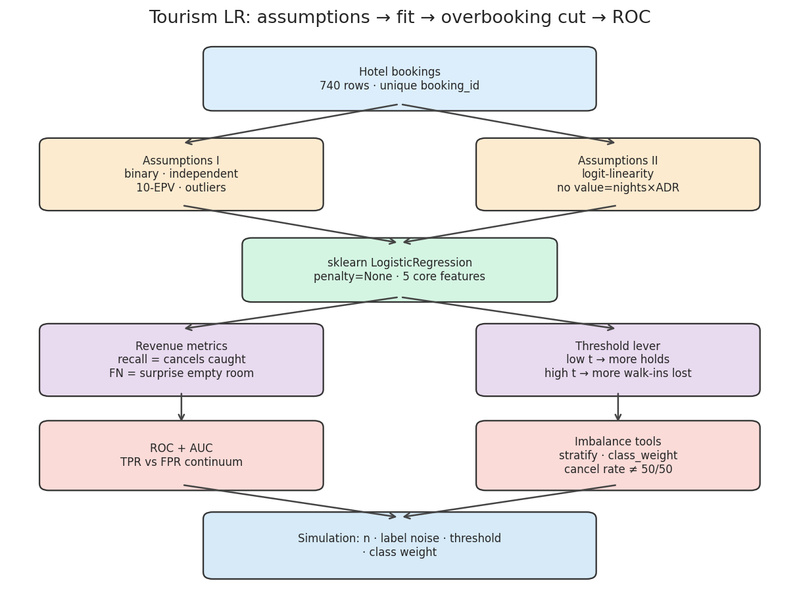
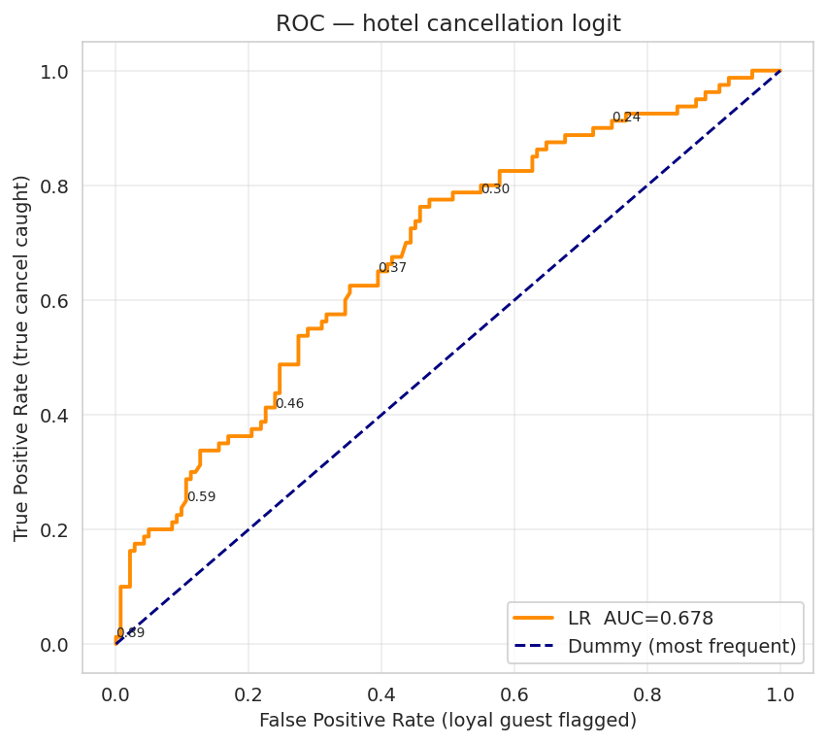
Left: assume → fit → overbooking cut → ROC. Right: ROC vs a most-frequent dummy. Sit toward t ≈ 0.25 when an empty room costs more than a hold.

Key Takeaways
- Do not keep booking_value next to nights — it is the same size signal twice.
- Accuracy is flattering because most guests stay. Quote catch-rate, empty-room FN and hold volume.
- t = 0.5 is a library default, not a GM policy. Move it with occupancy.
- class_weight='balanced' is the cheap lever when default recall is stuck near one-third.
- This is a first-pass risk score for overbooking conversations, not a reason to cancel a guest.

